Event Entry Instructions
- Log into the Motorsport Australia Portal
- Click on Event Entry
- Under upcoming events sort by state
- Click on ‘Tobin Brothers Funerals 2024 ACT Khanacross Series Rnd 1’
- Complete the Form.
- If you are using the event entry portal for the first time you will be required to complete vehicle details. Note the only mandatory Fields are:
  - Make
  - Model
  - Year
  - Colour
  - Capacity.
Note: If you are using a club car put xxx in the mandatory car fields.
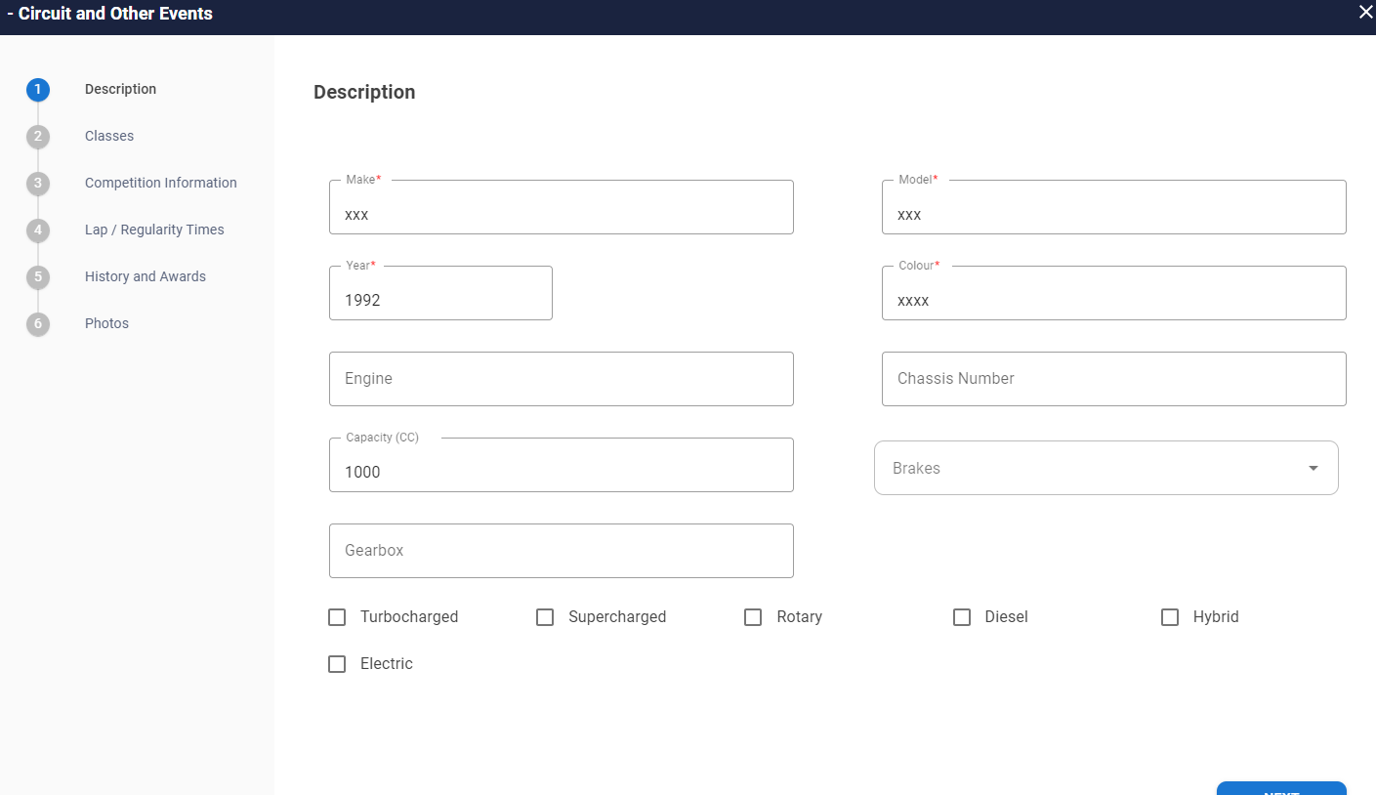
- Once the form is complete click confirm and select the payment option.

