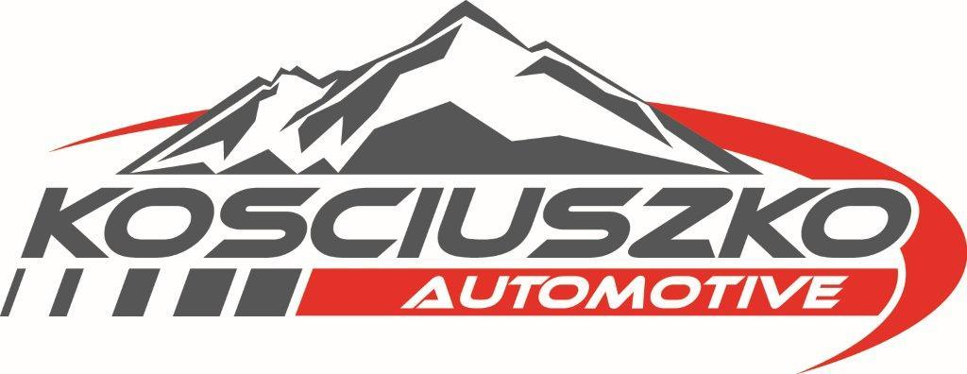 KOSCIUSZKO AUTOMOTIVE MONARO STAGES
SATURDAY 23RD OCTOBER 2021

EXPRESSION OF INTEREST – NOMINATION FOR ENTRY

RECEIVED |  | DEPOSIT PAID
___________________________________________________________________________________
_____________________________________________________________________________________________________

CONTACT DETAILS

Driver Name |  | Motorsport Australia Licence No

Address |  | State |  | Postcode

Email |  | Mobile/Phone

DEPOSIT

Deposit Payment |  | $200

EFT PREFERRED OPTION | WPAC BSB 032-778 A/C#: 583450 A/C NAME: LIGHT CAR CLUB OF CANBERRA

Deposit details – please provide your deposit information below

Name |  | Receipt No |  | Date Paid

Terms & Conditions
- This form is an expression of interest/nomination form only.
- The deposit of $200 must be paid with nomination to secure your place in the 2021 Kosciuszko Automotive Monaro Stages on 23rd October 2021
- The deposit will be retained and credited against the entry fee for the 2021 Kosciuszko Automotive Monaro Stages. Entry fee will be $690 less deposit ($490)
- The completed entry form must be submitted and paid in full by the close of entries for the 2021 Kosciuszko Automotive Monaro Stages. Close of entries will be Friday October 8th 2021.
- Withdrawal/refunds will be given, subject to written notification to the organisers to be received no later than 5pm, Wednesday 6th October 2021. After this date, your deposit will be forfeited.
- Please return the expression of interest/nomination form with deposit details completed above to monarostages@gmail.com
- A confirmation of your nomination/payment will be emailed to the email address you have provided.

Organisation for the event is now well underway. We look forward to receiving your nomination/entry for the event. Please do not hesitate to contact us if you have any questions. Looking forward to the 2021 Kosciuszko Automotive Monaro Stages – SEE YOU THERE!!!

